TASK – 2

**Jenkins Pipeline for Software Automation**

Name: Morgany J

                                                                                               Roll No: 22ISR028

A Jenkins Pipeline is used to streamline the **building, testing, and deployment** process by automating each stage of software development.

**Step 1: Access Jenkins and Create a Pipeline**

1. Sign in to Jenkins.
2. Navigate to **"New Item"** on the dashboard.
3. Provide a suitable name for the pipeline.
4. Select **"Pipeline"** as the project type.
5. Click **"OK"** to continue.

**Step 2: Configure the Pipeline**

**Step 3: Specify the Pipeline Script**

1. Choose **"Pipeline script from SCM"** under the **Pipeline Definition** section.
2. Select **"Git"** as the version control system.
3. Enter the repository URL containing the pipeline script.
4. Define the **script path** as Jenkins file

STEP -4:

Upload the files related to the project

Commit changes if necessary

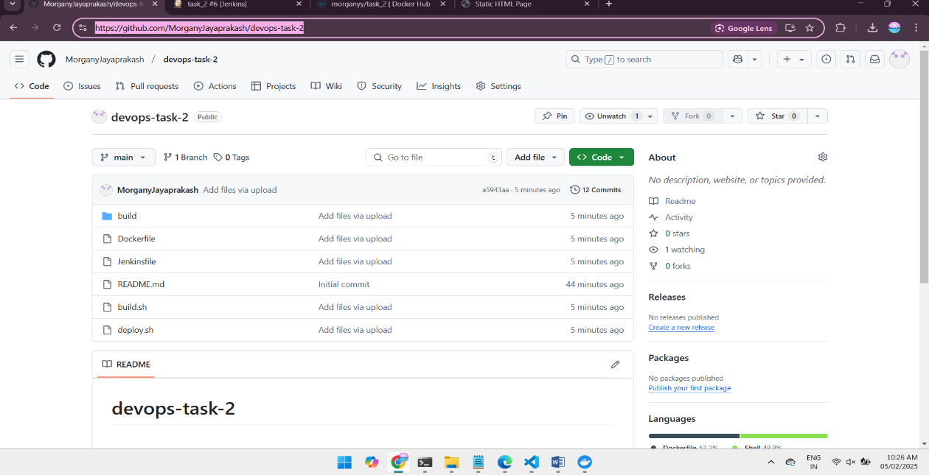

It is the script to use docker with username and password

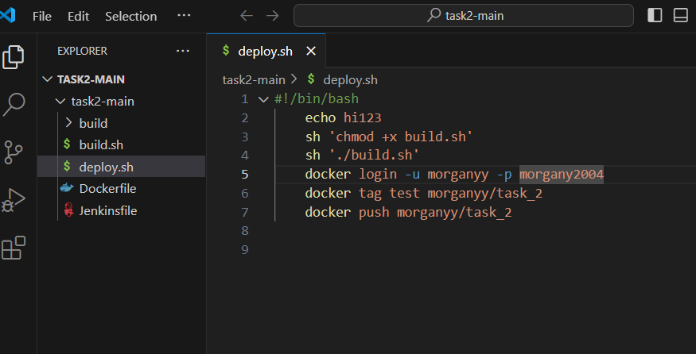

Index.html file

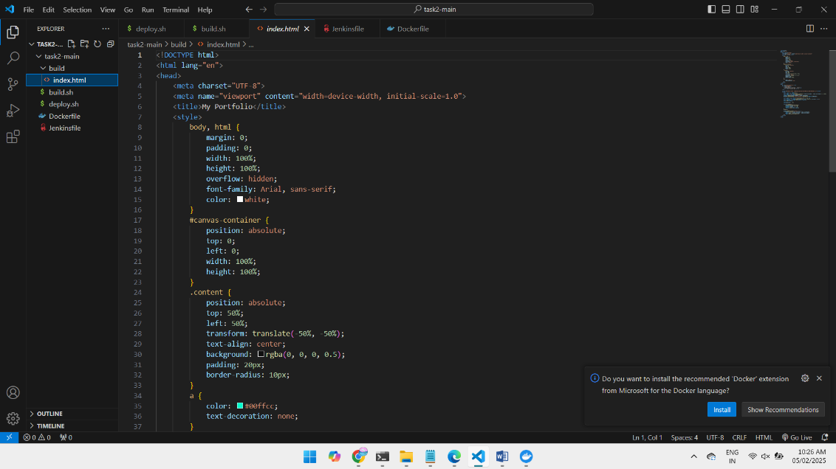

Command to run docker

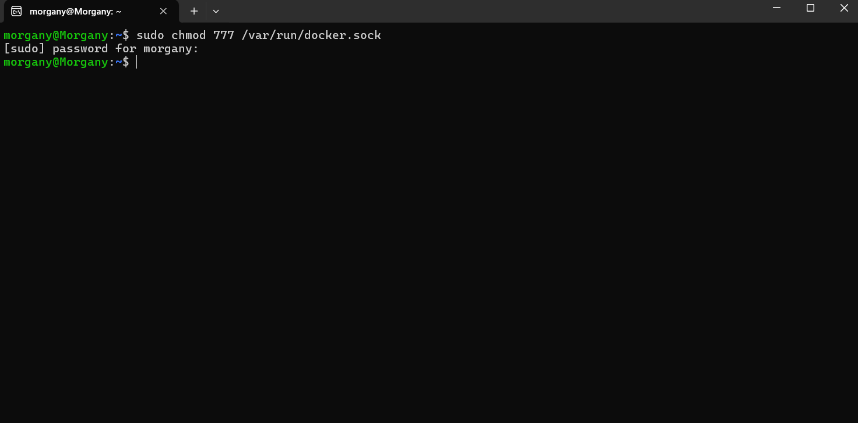

Pulling image from docker

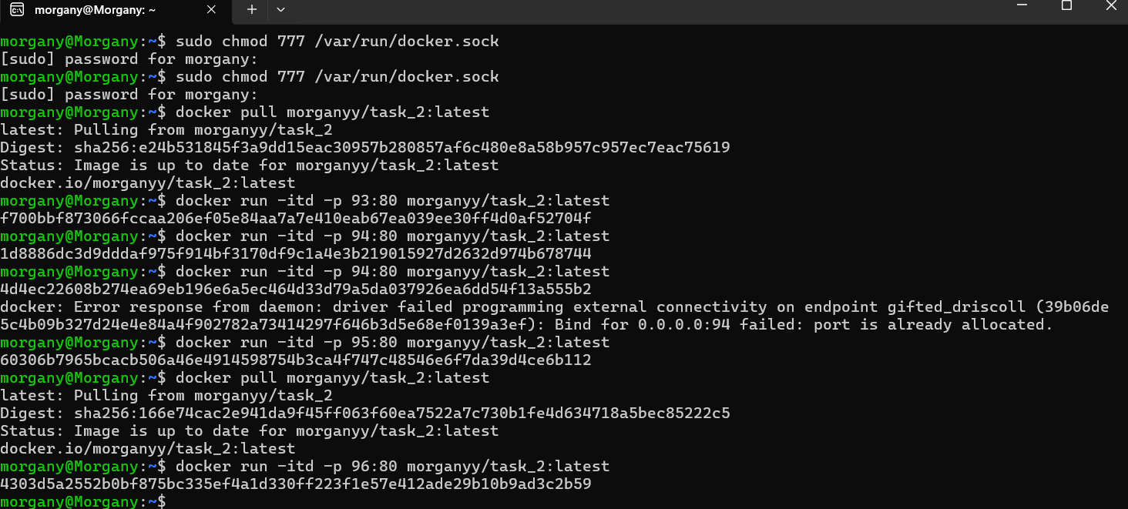

Running in jenkins

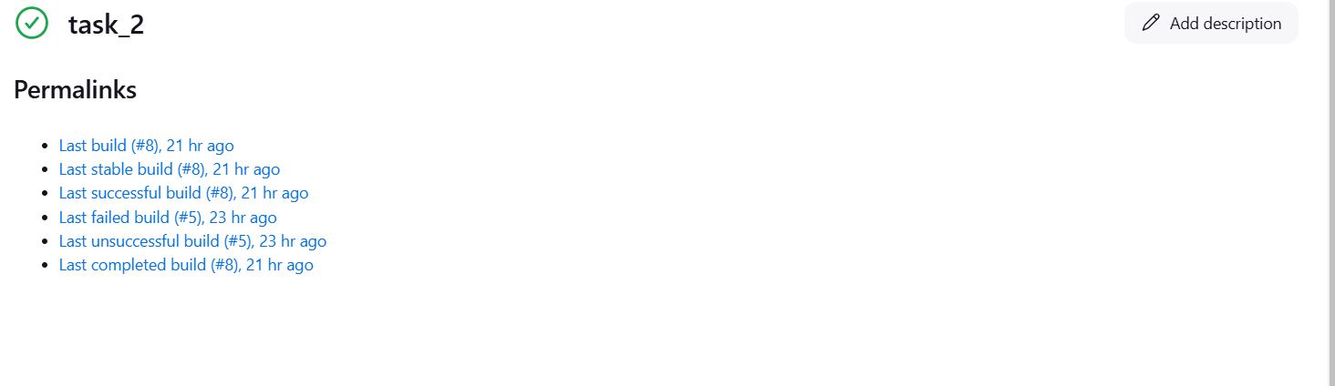

Console output: 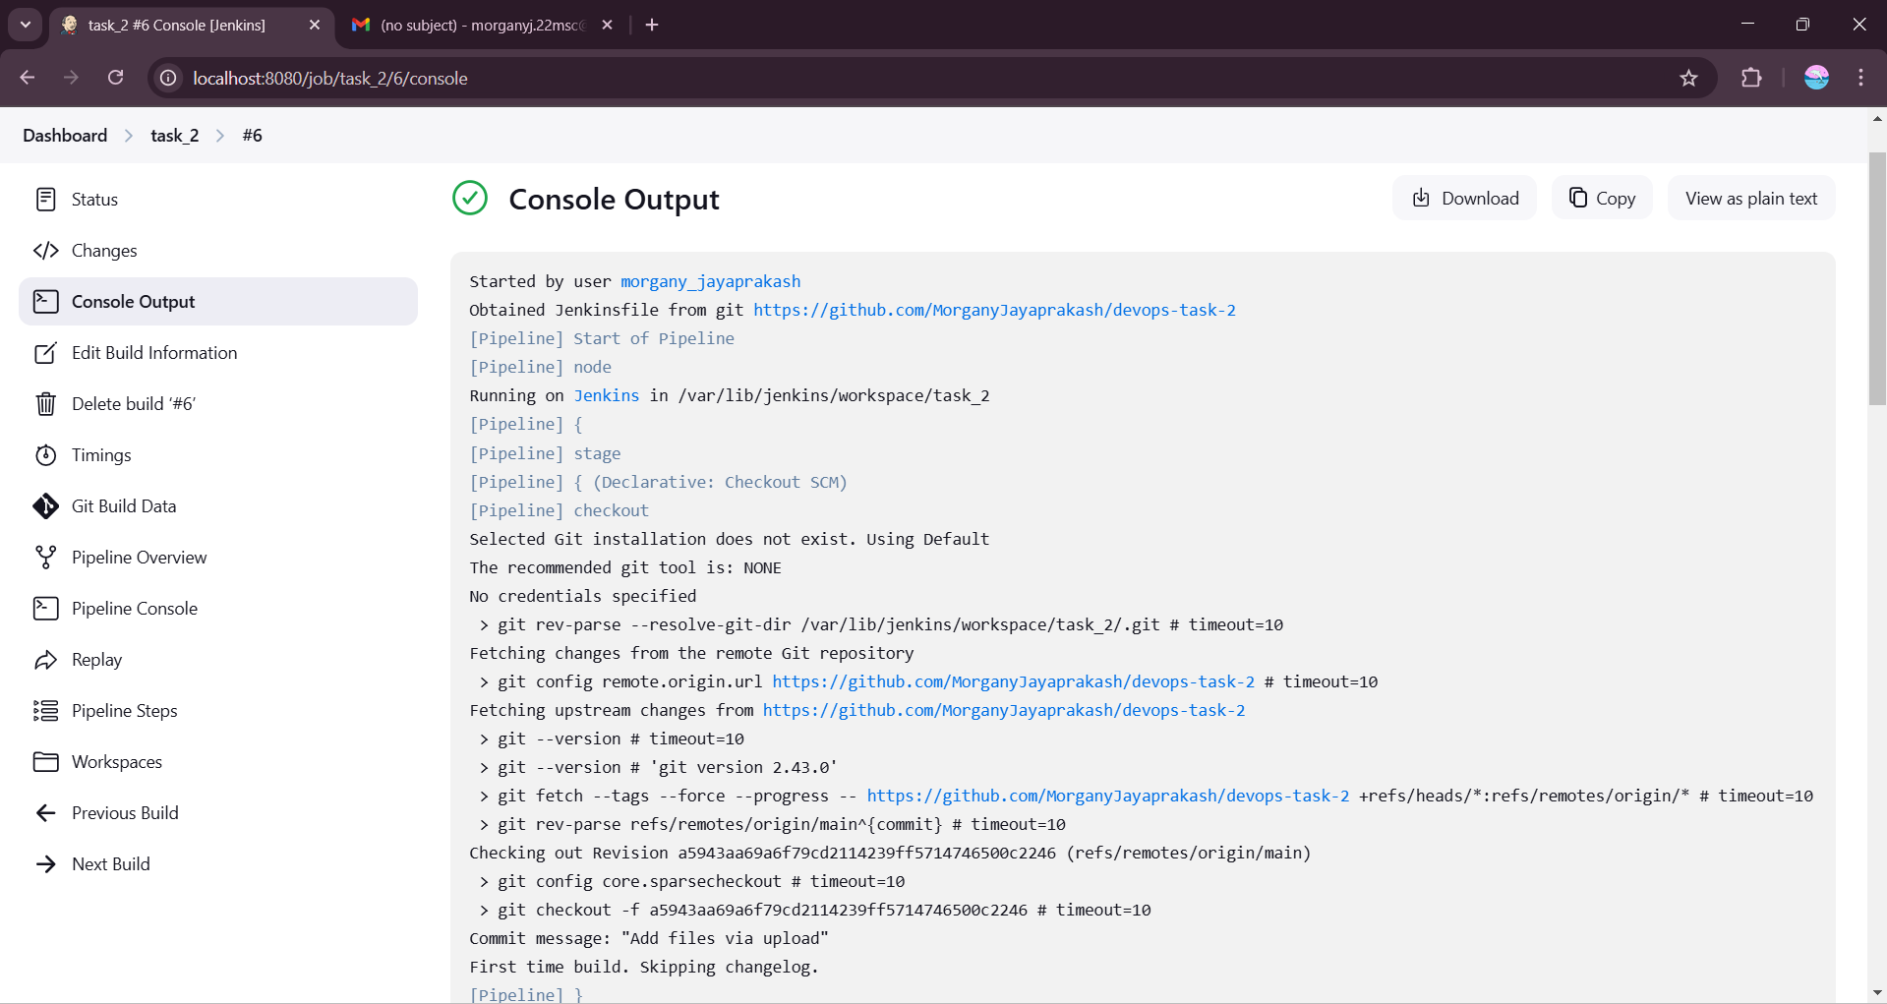

Output of my code:

